**Atari XL/XE A/V-Adapter Rev. 1**

**Testing**

# Test Setup

The tests were executed with an Atari XL/XE A/V-Adapter Rev. 0 and Rev. 1. These computers were used for testing:

* Atari 800XL
* Atari 800XE
* Atari 130XE (Rev. 0 only)

The retroTINK 2x (used with the HDMI capture device), the Framemeister (used with the TV) and a Samsung smart TV served as video equipment. A 1.5m RCA A/V cable connected the computer to the video equipment.

# Functional Test

The A/V adapter was connected to the computers. The 800XL displayed the composite video signal properly. The 130XE and the 800XE displayed both, the composite and the S-Video signal properly.

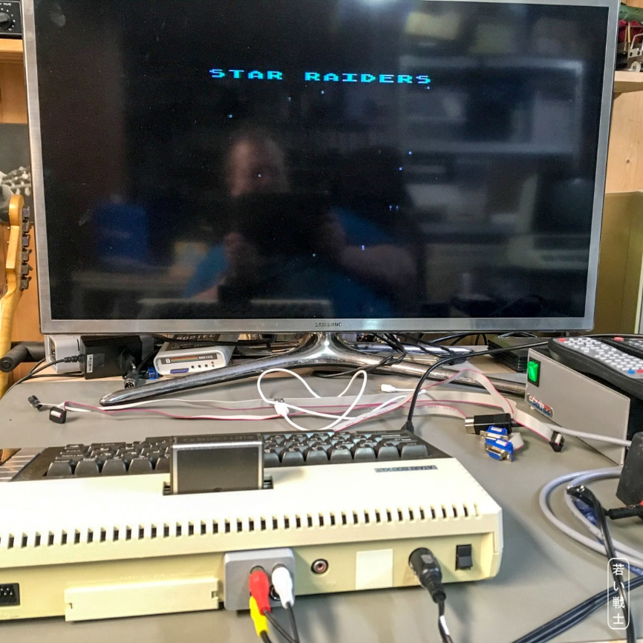

Figure 1: Testing with the 800XL

# Mechanical Testing

The Atari XL/XE A/V-Adapter Rev. 1did not block any port of the said computers. It fits under the protrusion of the computers’ back side.

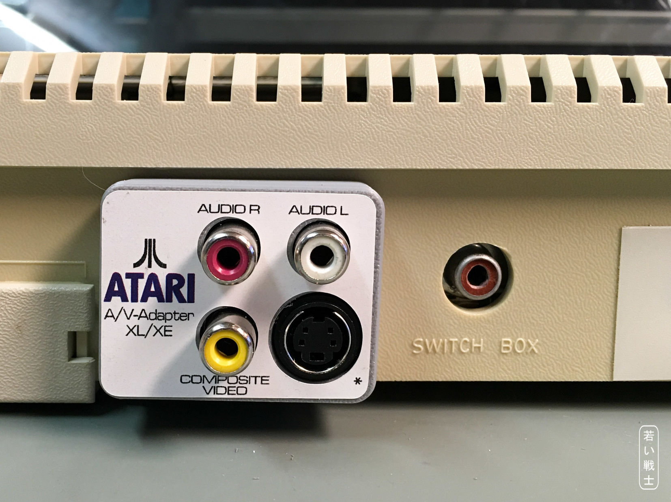

Figure 2: Test fitting with the 800XL

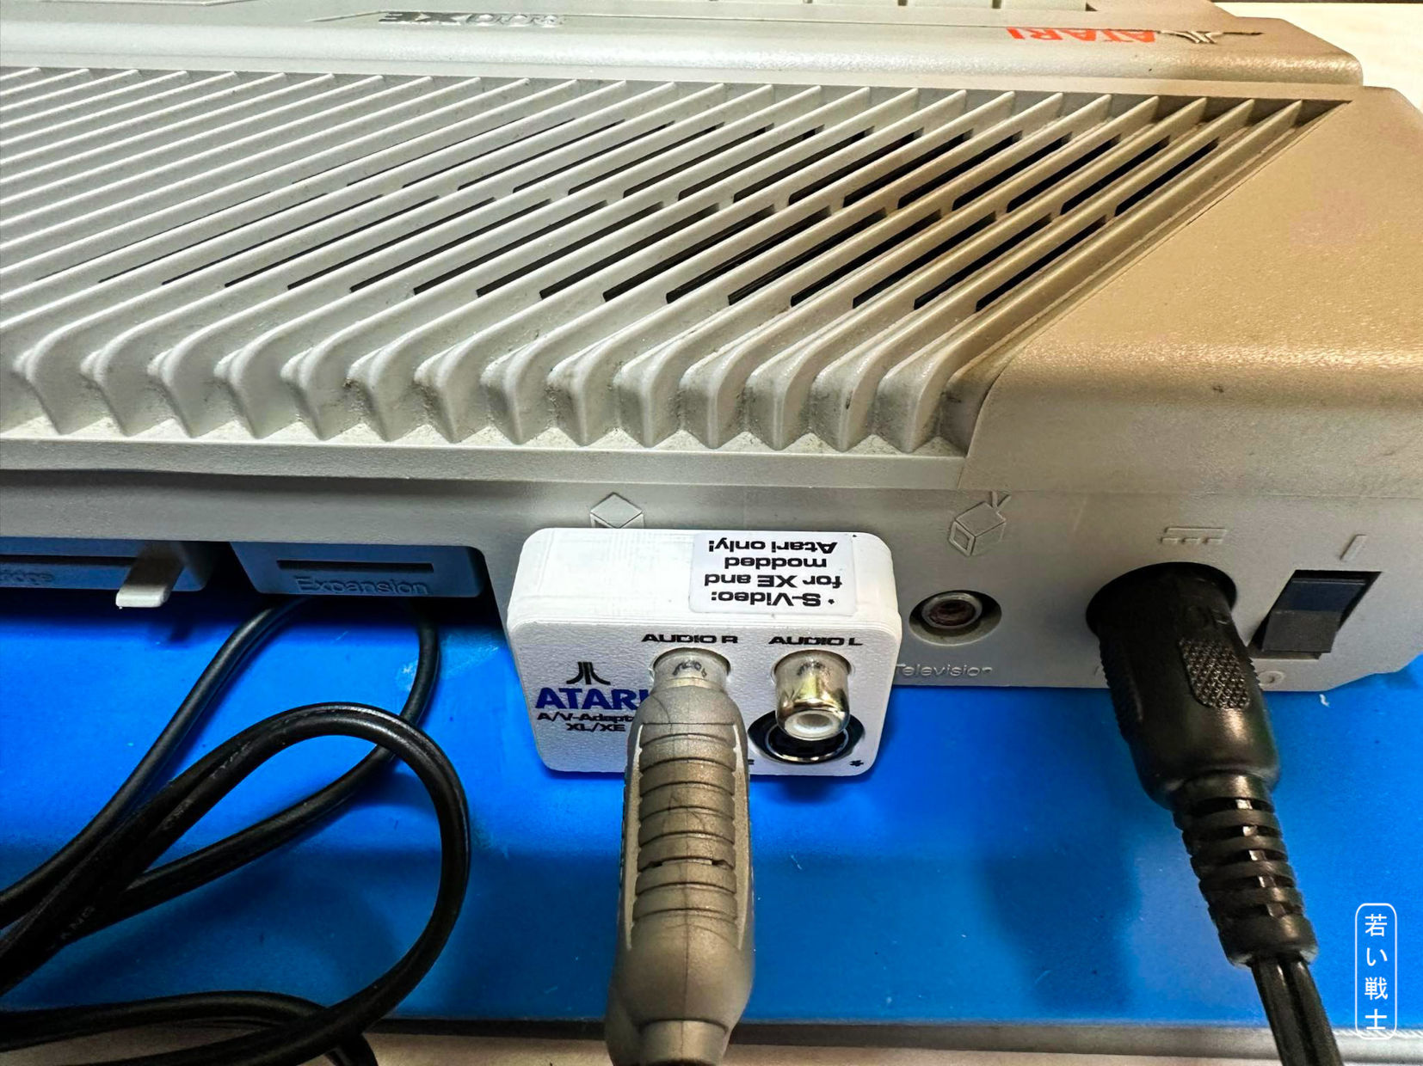

Figure 3: Test-fitting with the 800XE

# Conclusion

The Atari XL/XE A/V-Adapter Rev. 1 works well with different equipment. The video quality depends very much on the used video equipment. The video adapter will not improve the picture of the computers, since it is passive only, but since it allows to use good, off the shelve cables, it is superior to most hand-made custom cables.

**The** Atari XL/XE A/V-Adapter Rev. 1 **is fully functional.**